REGISTRATION FORM ANNUAL GENERAL MEETING
Santiago de Compostela, A Coruña (Spain),
22 June to 23 June 2023

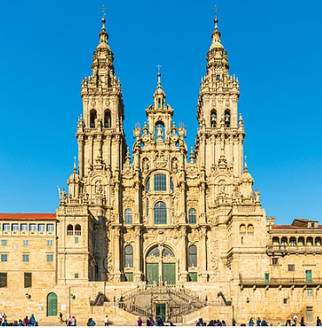

Participant's name:

Name of accompanying person:

Company/Organisation:

Country:

e-mail:

Will participate in the following meetings and activities:

Thursday, 22 June 2023 PARADOR DE SANTIAGO, HOSTAL DOS REIS CATÓLICOS

19.00-23.00 Gala Evening – location to be announced

YES NO

Please indicate the number of accompanying persons: ……

Friday, 23 June 2023 OPEN ASSEMBLY – CIDADE DA CULTURA OF GALICIA
Fontán Building

08.30-09.00 Transfer from the hotels…

YES NO

Please indicate the number of accompanying persons: ……

09.00-14.00 General Assembly (open part)

YES NO

Please indicate the number of accompanying persons: ……

14.00-15.30 Lunch

YES NO

Please indicate the number of accompanying persons: ……

15.30-16.00 Transfer to the city…

Please indicate the number of accompanying persons: ……

18.00-19.30 Networking tour
To be confirmed

YES NO

Please indicate the number of accompanying persons: ……

